Software Requirements Specification
for
BlueTToMS

Prepared by Jake T. Manlupig
BS Computer Engineering 5
Software Engineering Requirement
Table of Contents
Table of Contents ii
Revision History ii
1. Introduction 2
1.1 Purpose 2
1.2 Intended Audience and Reading Suggestions 2
1.3 Product Scope 2
1.4 References 2
2. Overall Description 3
2.1 Product Perspective 3
2.2 Product Functions 3
2.3 User Classes and Characteristics 4
2.4 Operating Environment 4
2.5 Design and Implementation Constraints 4
3. External Interface Requirements 5
3.1 User Interfaces 5
3.2 Hardware Interfaces 6
3.3 Software Interfaces 7
3.4 Communications Interfaces 7
4. System Features 8
4.1 Master and Slave 8
4.2 Auto Avoid 8
4.3 Dance………………………………………………………………………………...…………….9
4.4 Android BT Controlled…………………………………………………………………...……......9
5. Other Nonfunctional Requirements 10
5.1 Performance Requirements 10
5.2 Safety Requirements 10
5.3 Security Requirements 10

Revision History
Name | Date | Reason For Changes | Version

Introduction

Purpose
The purpose of this product is to replicate an open-source project and add a function that it can be operated by the use of a Smartphone, an Android Application and Bluetooth.

Intended Audience and Reading Suggestions
This document is intended towards developers, project managers, marketing staff, users, testers, and documentation writers. This document contains data of BlueTToMS where it specifies the different product functions, materials used, how it is made and how it works with the help of different technology.

Product Scope
Arduino IDE – Open-source software makes it easy to write code and upload it to the board. It runs on Windows, Mac OS X, and Linux. The environment is written in java and based on Processing and be used with any Arduino Board.

Android Studio – The official IDE for Android. It provides the fastest tools for building apps on every type of Android device. World-class code editing, debugging, performance tooling, a flexible build system, and an instant build/deploy system all allow you to focus on building unique and high-quality apps.

References
https://www.hackster.io/cparrapa/otto-diy-build-your-own-robot-in-one-hour-5f2a1c

https://developer.android.com/studio/index.html?gclid=EAIaIQobChMIhOz9o-6U2AIVTB0rCh2XQwTNEAAYASAAEgJYffD_BwE

https://www.arduino.cc/en/Main/Software

Overall Description

Product Perspective
BlueTToMS is an upgraded version of the original product Otto DIY which is an interactive robot that anyone can make and very easy to 3d print and assemble, walks, dances, makes sounds and avoids obstacles. Whereas, BlueTToMS can be controlled by using an Android Application and also uses Bluetooth to connect and a Master and Slave connection between to robots.

Product Functions
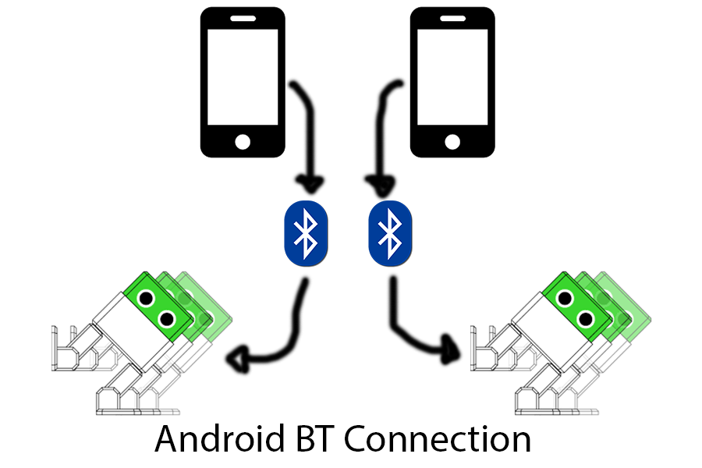
- Android BT Controlled
- Master and Slave
- Auto Avoid
- Dance

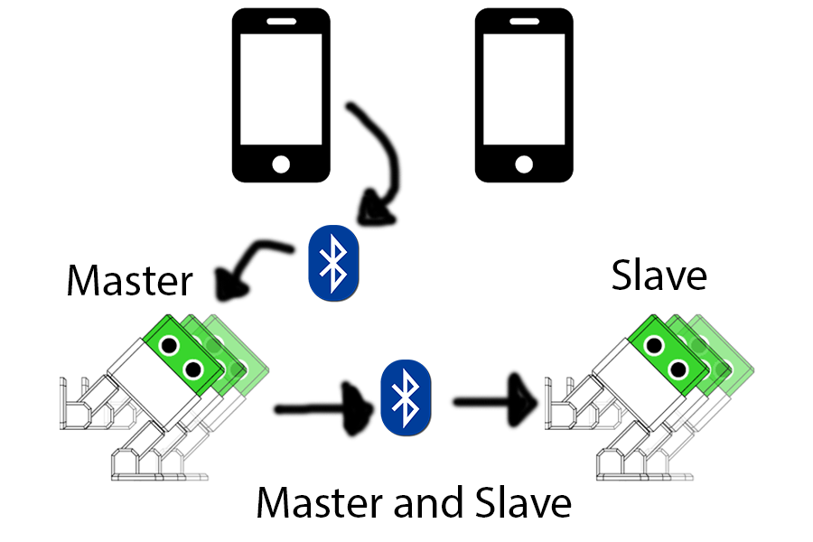

User Classes and Characteristics
In this modern day it isn’t new that technology is part of our daily life. Children are the anticipated users of the product as it is more concentrated as entertainment and be entreprenerd in the market with children as the main target.

Operating Environment
The operating environment of the software application of BlueTToMS must be an Android phone, at least it has an Android version of 4.4.2 (KitKat). The software application takes up only 3.00MB of memory of the phone.

Design and Implementation Constraints
- BlueTToMS cannot avoid obstacles when dancing.
- When dancing, it cannot be forcibly stopped using the Android application unless switched off.
- Bluetooth connection can’t work more than 10m of distance.
- One phone can’t have more than one connection at a time.
- Dance steps are programed in advance.
- In avoiding obstacles, BlueTToMS will always go the right side.
- Must use 9v battery for the Master BlueTToMS while for the slave BlueTToMS 6v is enough.
- Master and Slave BlueTToMS have the same movements when in master and slave function.

External Interface Requirements

User Interfaces
- PAIRED DEVICES button – when pressed, paired Bluetooth devices will appear and can be selected to connect to the desired BlueTToMS and it will proceed to the next activity of the application.
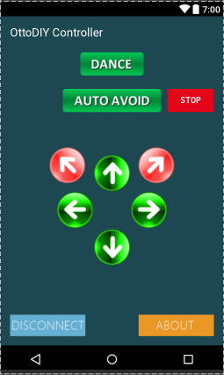
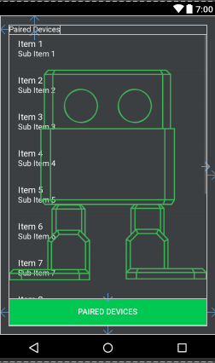

- DISCONNECT button – disconnect with the current BlueTToMS connected.
- ABOUT button – displays information about BlueTToMS.
- DANCE button – BlueTToMS will start to dance.
- AUTO AVOID button – it will start to walk forward and if there’s an obstacle it will step backward and turn to avoid it.
- STOP button – it will stop the AUTO AVOID function of BlueTToMS.
- DIRECTION buttons – it will move as soon as one these buttons are pressed. The direction where BlueTToMS must be considered in controlling how it moves.

Hardware Interfaces
In the hardware interface of the product, it is controlled through HC-05 and Arduino Nano where HC-05 receives the command from Android Application. Then, Arduino Nano will process and execute the respective encoded programs.

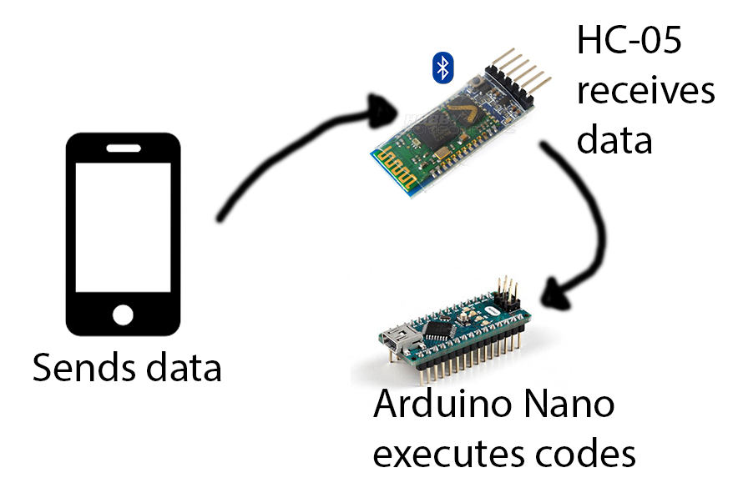

Software Interfaces
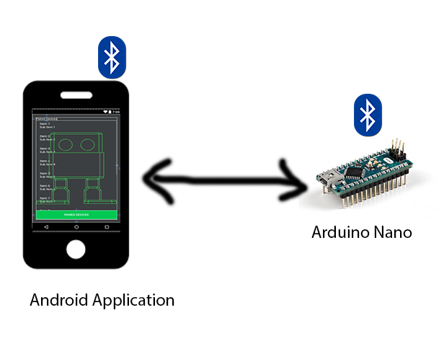
Connection between this product is mainly focused on the Android Application and Arduino Nano. Android Application uses Bluetooth network stack, which allows a device to wirelessly exchange data with other devices. On the other hand, Arduino Nano has libraries (Servo.h, Oscillator.h, EEPROM.h, Newping.h and SoftwareSerial.h) which it uses to operate the different components used in BlueTToMS.

Communications Interfaces
Communication Interfaces used in this project is the Bluetooth. Bluetooth is a standardized protocol for sending and receiving data via a 2.4GHz wireless link. It’s a secure protocol, and it’s perfect for short-range, low-power, low-cost, wireless transmissions between electronic devices.

System Features

Master and Slave
4.1.1 Description and Priority
The main function which allows a user to command one BlueTToMS (Master) then it will send commands to other BlueTToMS to control them. It is rated 9 as it is the highest priority of the product.
4.1.2 Stimulus/Response Sequences
- User must turn on Master BlueTToMS and Slave BlueTToMS and wait for them to connect to each other.
- User must connect his/her phone to the Master BlueTToMS
- User can now send commands to BlueTToMS
4.1.3 Functional Requirements

REQ-1: Bluetooth connection, if there’s no connection BlueTToMS will not move.
REQ-2: Power Supply, if there’s no power or not enough supply for the components the BlueTToMS will not be powered ON.
REQ-3: Arduino Nano, it is the main processor for the BlueTToMS, if not present then there will be nothing to process the commands receive from phone.
REQ-4: Phone, used to send commands to BlueTToMS. Any BlueTToMS will not work without a phone.

Auto Avoid
4.2.1 Description and Priority
A function which allows a BlueTToMS to dodge an obstacle blocking its path by backing up and turning right. This function can be stopped using the Stop button. It is rated 7 as the priority of the product.

4.2.2 Stimulus/Response Sequences
- When connected to a BlueTToMS, user will be able to press Auto Avoid button.
- BlueTToMS will automatically walk where it is facing and stop after a few steps and the Ultrasonic Sensor will read if there’s any obstacle in range.
- If there is an obstacle detected, it will walk backwards and turn right and read again if there’s still an obstacle.
- If there’s not an obstacle it will continue to walk forward.
- User can press Stop button and it will stop and revert to its standardl state.

4.2.3 Functional Requirements

REQ-1: Bluetooth connection, if there’s no connection BlueTToMS will not move.
REQ-2: Ultrasonic sensor, used to detect obstacle in front of BlueTToMS.
REQ-3: Phone, used to send commands to BlueTToMS. Any BlueTToMS will not work without a phone.

Dance
4.3.1 Description and Priority

A function which allows a BlueTToMS to dance to its pre-programmed movements to match a specific song. It is rated 8 as the priority of the product.

4.3.2 Stimulus/Response Sequences
- When connected to a BlueTToMS, user will be able to press Dance button.
- BlueTToMS will automatically dance to its pre-programmed dance movements.
- After a series of movements, it will stop and will be in its standard state.

4.3.3 Functional Requirements

REQ-1: Bluetooth connection, if there’s no connection BlueTToMS will not move.
REQ-2: Pre-programmed movements of the BlueTToMS.
REQ-3: Phone, used to send commands to BlueTToMS. Any BlueTToMS will not work without a phone.

Android BT Controlled

4.4.1 Description and Priority

A function which allows a user to connect to a BlueTToMS. It is rated 9 as it is also the highest priority of the product.

4.4.2 Stimulus/Response Sequences

- User must turn on the Bluetooth of BlueTToMS and his or her phone.
- User must pair the Bluetooth of his or her phone to the desired BlueTToMS.
- User must open the mobile application in his or her phone after pairing.
- User must press the Paired Devices button and select the name of the BlueTToMS to connect.
- After selecting, the user can now command the BlueTToMS.

4.4.3 Functional Requirements

REQ-1: Bluetooth connection, if there’s no connection BlueTToMS will not move.
REQ-2: Mobile Application, used to connect and to command a BlueTToMS.
REQ-3: Phone, used to send commands to BlueTToMS. Any BlueTToMS will not work without a phone.

Other Nonfunctional Requirements

Performance Requirements
In performing connectivity with a Bluetooth device, the user must wait 3 – 10 seconds until both devices is completely connected to each other. A 9v battery must be needed for a Master BlueTToMS while a Slave BlueTToMS can be operated using 6v battery.

Safety Requirements
The screws must be screwed tightly in order to prevent any dislocation of a part when it is performing any commands from the user. The BlueTToMS is not a water-proof robot, user must be careful for it to be not wet because it can lead to the malfunction of any electronic part inside especially the Ultrasonic sensor which is sticking out of the BlueTToMS.

Security Requirements
A Creative Commons (CC) license is one of several public copyright licenses that enable the free distribution of an otherwise copyrighted work. A CC license is used when an author wants to give people the right to share, use, and build upon a work that they have created.
https://creativecommons.org/licenses/by-sa/2.0/
https://www.hackster.io/cparrapa/otto-diy-build-your-own-robot-in-one-hour-5f2a1c

